Building and Key Use Policy
Date of Policy Approval: 7/11/2002; 9/17/2014; ________
Policy Updated: 8/1/2025 Updated Procedure for Locking Up: 6/30/2026
Policy Owners: Building and Grounds Committee and Finance Coordinating Council
The Second Unitarian Church of Omaha should be a secure building for its staff, members and renters to use. Except for the Safe Deposit Box, and file cabinets with Personnel and Religious Education records, the Office Administrator is responsible for issuing church keys and building access codes in accordance with the Procedures listed below.
According to the Church Standing Rules, the Vice Chairperson of the Board shall “Serve, with the Minister, as the final authority for issues regarding reserved use of the church property and facilities.” The Office Administrator, in processing Calendar Reservation Forms and Building Rental Requests, is responsible for building use assignments and posting the assignments on the Church Calendar. Building use conflicts or misuse of facilities will be elevated to the Minister and/or Vice Chairperson.
There is to be no duplication of church keys by any key holder other than the church staff or Building & Grounds Committee Chair.
Building and Key Use Procedures
Procedures Updated: 12/31/2024 Final Draft
Building Access
The front exterior doors to the church are equipped with a keypad entry lock. The remaining exterior entry doors have key-operated locks.

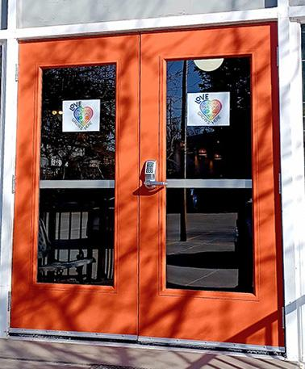  Front Door of the Church |  | 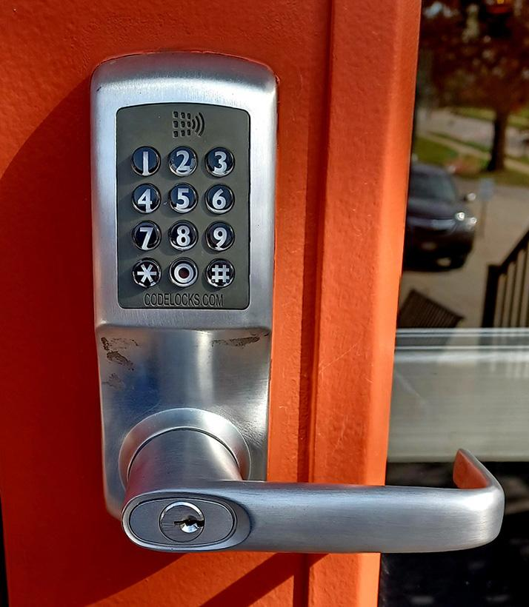  Keypad Lock on the Front Door

Procedure for Entering the Church via the Front Door
To enter the church, slowly input your 4-digit code into the keypad lock on the door. If the code is accepted, the keypad will light blue and you can turn the door handle to open the door. If the code is rejected, the keypad will light red.
To unlock the front door, use the hex wrench located on the top-left of the inside door frame. There is a spare hex wrench in the top-left door of the Welcome Desk. On the panic bar on the inside of the door, there is a small round hole. Depress the panic bar, insert the hex wrench in the hole, and turn the wrench clockwise. That will lock the panic bar in the depressed (unlocked) position. Be sure to return the wrench to its proper storage location.
Procedure for Disarming the Security System
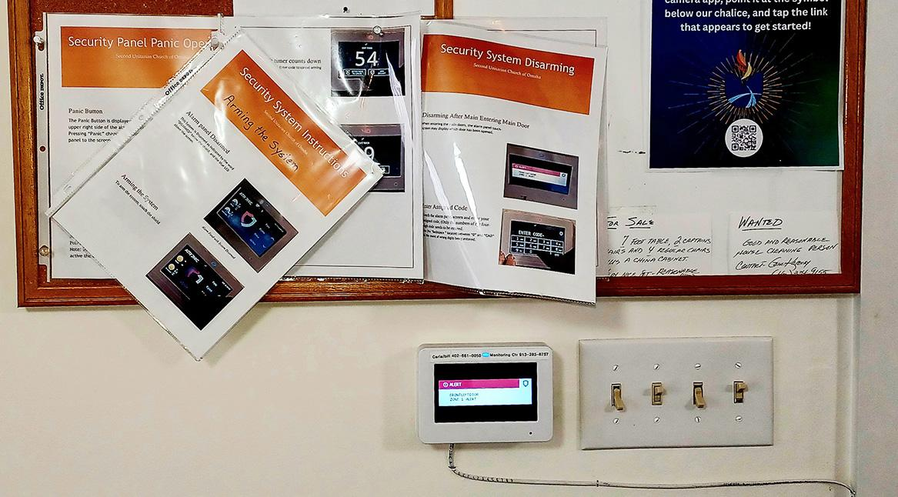
View of the Atronic Security System touch screen. The bulletin board above the touch screen has operating instructions.
After entering the building and the security system is armed, the security system touch screen located left (east) of the front door will beep allowing 60 seconds to disarm. If armed, the light on the top of the keypad will be red. If disarmed, the light will be blue. During the countdown, a valid entry code must be entered on the keypad screen to disarm. Failure to disarm the system within 60 seconds will trigger an alarm. The siren will sound and text alerts will be sent to the Technology and Building & Grounds chairs. After the alarm has sounded for two minutes, the Atronic Security Desk will be notified and police will be called. Additional Security System Instructions are posted on the bulletin board above the touch screen.
Key and Entry Code Management
The Office Administrator is responsible for the issuance of keys and key codes and will keep a logbook of signatures of key code and key holders. Following is the criteria that must be met in order to receive a key code to the church. Unique key codes are to be issued to church leaders and staff. Key codes are also used to arm and disarm the church security system.
- All church staff will be issued key codes. This includes but is not limited to Minister, Office Administrator and Director of Religious Education.
- The janitorial service contractor will be issued a key code for its employees.
- Current Board members and Treasurer.
- Committee chairs of recognized church committees and committee members who need access.
- Volunteer Money Counters
- Members of the church with an appropriate need for use during non-business hours will be issued a temporary code.
- Regular renters of the church space will each be issued key code .
- One-occasion renters will be issued temporary key codes.
An “override” or master key is available for opening any keypad-entry lock in case of battery failure or malfunction of the electronic mechanism. This master key will be kept in the Church Office. Church Staff, and the Building and Grounds Committee Chair can enter the building using their key to the Basement Double Door.
Each person requesting and given a key code or key will be recorded in a logbook and will receive a letter of opening and lockup procedures. (See last page.) It is expected that each committee chair will report to the church office all meeting dates in advance so that the church office is aware of who is using the building at given times.
Any person who needs a key code for a stated reason may receive a temporary key code from the Office Administrator. After the stated need is complete, the key code will be erased from the lock. To maintain key distribution control, key code holders are not to share their key codes.
The staff key codes will be changed following any change in church staff.
The Church Staff and Board (along with the Building and Grounds Committee) reserves the right to change codes as needed if there are continuing unresolved problems with locks, break-ins or doors left open and unlocked.
Church Keys
Door Keys – The supply of door keys are kept in a secure location in the Church Office. The Office Administrator will log the issuance and return of the keys using the same logbook used for key codes.
Safe Deposit Box Keys – The church has a safe deposit box at the Core Bank branch office near the northwest corner of 120th St & West Center Road. The Office Administrator keeps the safe deposit box key in a secure location in the Church Office. The second key is kept by the Treasurer. Access requires 2 of the 3 signers on the bank account to be present. Authorized signers include the Treasurer, the Board Chair and the Board Vice Chair. An inventory is maintained by the Treasurer at all times so items added to or removed from the safe deposit box are to be documented. The Office Administrator will check out and check in the safe deposit key with entries in the same logbook used for key codes.
Lockbox Key Policy – The Lockbox Key Policy adopted in June 2009 is abolished and incorporated into this Policy. The Church Lockbox is used for the short-term secure storage of Sunday Offering and other income awaiting counting and preparation for deposit. The lockbox key shall be kept in a secure location in the church. The Office Administrator shall have access to the key. [From separate Lockbox Key Policy]
Padlock Keys – Several items outside the church are secured with padlocks (park benches, extension ladder, garden tool & supply area, landscape artwork). Keys for the padlocks are hanging on wall hooks in the northwest corner of the Church Office. There is also a key for the Doggy Potty Station located on the east side of the Church Parking Lot. It is not necessary to check out these keys or maintain a log of key users. However, users of these keys are requested to return them to the Church Office promptly after use.
Keys to File Cabinets containing confidential / sensitive information
- Treasurer/Finance Committee 4 drawer file cabinet in the Church Office (Key#78) - One key is kept by the Treasurer. The Office Administrator keeps a backup key in a secure location in the Church Office. The OA can issue the backup key to the FCC Chair and Check signers. Within the 4 drawer file cabinet are two locked security boxes. Both the Treasurer and Board Chair have a key. Access is limited because the contents includes blank checks and sensitive banking information obtained for ACH withdrawals. These secure boxes include:
  - #1 Key#JE45: Blank Checks: Treasurer is responsible for ensuring the OA has sufficient checks for processing and the Board Chair is a back-up.
  - #2 Key#JE07: ACH Authorization Forms; ACH Cancelled Forms; 1099 Misc – IRS; W2 forms; Bank Signature cards, Resolutions, ACH Originator Agreement, Safe Deposit Box; Online Banking Agreement; Voided Checks; W-2 Forms.
The Treasurer is responsible for transfer of keys to next Board Chair. The 4 drawer file cabinet and the two additional boxes within are to be kept locked at all times. The Treasurer will maintain the Key Log for keys to 1) Safe Deposit Box; 2) Treasurer/Finance Committee 4 drawer file cabinet; 3) Locked security box #1; and 4) Locked security box #2 The 4 drawer file cabinet and the two additional boxes within are to be kept locked at all times.
- Personnel File Cabinet – Located in the Minister’s Office. Only the Minister is issued a key to this file cabinet.
- Director of Religious Education File Cabinet - Located in the Director Religious Education Office. Only the DRE is issued a key to this file cabinet.

Procedure for
Locking Up

- Close Windows
- Turn Off Lights (Note: Lights in the Downstairs Unisex Restroom are motion activated and turn off automatically after about 10 minutes. Lights in the stairwells don’t turn off.)
- Make sure all exterior doors are locked including the double doors in the RE worship area. To lock the Front Door, use the hex wrench on the top-left of the door frame. Insert the wrench in the small hole on the inside panic bar and turn counter-clockwise. An extra hex wrench is located in the top-left drawer of the Welcome Desk.
- Verify that no one else is in the building. Check downstairs, restrooms, etc. (Also check that water is not running in any of the restrooms or kitchen.)
- Arming the Security System – After verifying that all the building exit doors are locked, arm the security system using the control pad located on the Entryway wall to the left (east) of the Front Doors. To arm, press the shield in the center of the screen, then press the white block on the right side of the screen. The system will then request that you enter your Security Code which is the same as your door keypad lock code. Once your command is accepted, the light on the top of the control pad will turn from blue to red and begin a 60-second countdown to allow you time to exit the building.
- After locking the Front and Basement doors and leaving the building, pull on the handles to be sure the doors are latched and secure.
Updated June 30, 2026

